

FreshMart: Why Is Our Basket Getting Smaller?
Business Analyst Workflow — how I worked through the case study
Structured against the six research tasks in the assignment brief, with the Python steps and outputs used to reach each conclusion.

Task 1 — Define and Scope the Problem
The brief opened with a hunch, not a metric: “people are buying less per visit.” Before touching a chart, I pinned down what “basket size” would mean for this analysis and over what window.
- Defined basket size two ways: rand value (basket_value_zar) and item count (num_items) — since the brief itself warns these can move independently.
- Because the extract only covers 2025, I used H1 (Jan–Jun) vs H2 (Jul–Dec) as the before/after comparison, and flagged this explicitly as a stand-in for the business's external “+6% YoY footfall” claim rather than a true year-over-year read.
- Ran the chain-wide numbers first to confirm the paradox was real before looking for causes.
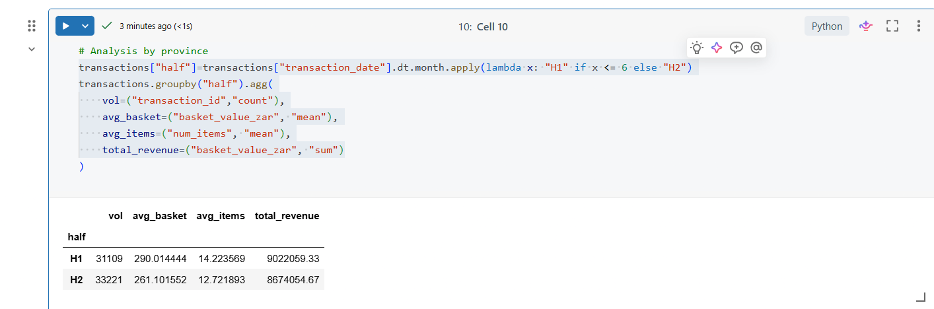
Confirming the paradox: volume up, average basket and items down, revenue roughly flat-to-down.
Result: the effect is real and measurable — average basket value fell 10.0% and items per basket fell 10.6% from H1 to H2, while transaction volume rose 6.8% and revenue slipped 3.9%. That gave me a quantified problem statement to investigate, not just a feeling from store managers.

Task 2 — Stakeholders and Hypotheses
I mapped the four groups named in the brief to what each of them would need from the analysis, since the report and deck both had to speak to a non-technical steering group.
Stakeholder | What they care about
Head of Retail Operations | Whether the basket-shrink story is real, how big it is, and what to prioritise
Merchandising Lead | Whether product mix or availability is driving smaller baskets
Pricing Manager | Whether pricing or competitor pricing pressure is the cause
Store Managers | Store- and operations-level issues they can act on directly

From the starter checklist and the brief's own suggested causes, I set four testable hypotheses before opening the data further:
- H1 — Competitive pressure: baskets fall faster at stores near a new discount competitor.
- H2 — Behavioural shift: shoppers are splitting one big trip into several smaller ones (mix-shift, not just a falling average).
- H3 — Loyalty effect: non-loyalty shoppers are driving more of the decline than loyalty members.
- H4 — Operational availability: stockouts are suppressing basket value on affected store-days.
For each, I noted in advance what evidence would support or reject it — e.g. H1 needed a before/after comparison keyed to each store's actual competitor_open_date, not just a chain-wide average.

Task 3 — Data Preparation and Quality
Before testing any hypothesis, I profiled all three tables (Transactions, Stores, Stockouts) for shape, coverage, missing values and duplicates.
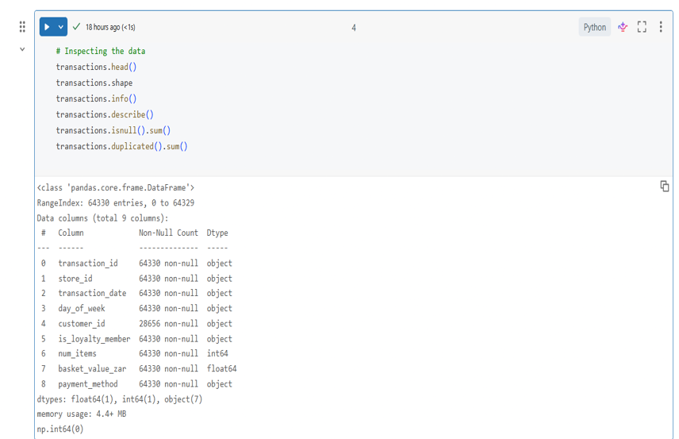
Initial profiling in the notebook: shape, dtypes, describe(), nulls and duplicate checks on the Transactions table.
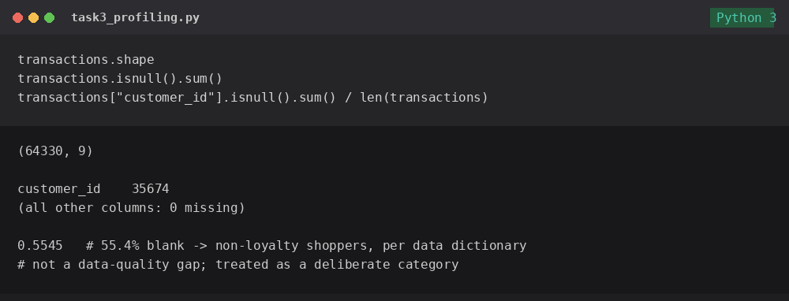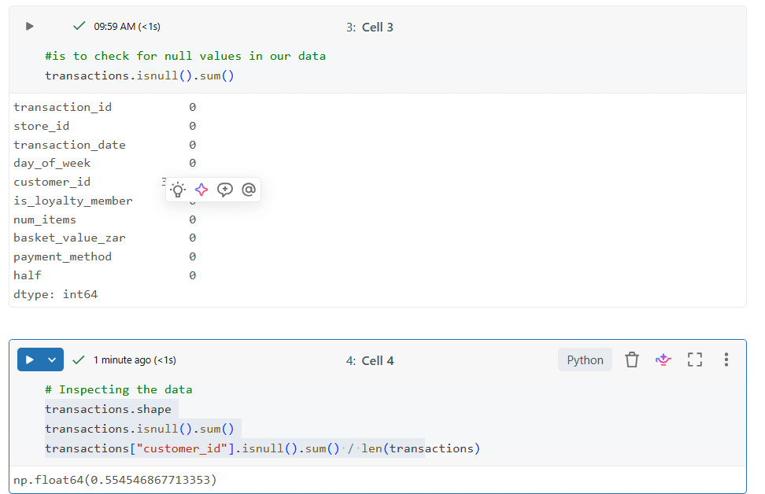
Checking the one real gap found — blank customer_id — against the data dictionary before treating it as an issue.
Findings from profiling:
- 64,330 transactions, Jan–Dec 2025, no duplicate transaction_ids.
- The only missing values were in customer_id (35,674 of 64,330 rows, 55.4%). Cross-checked against the data dictionary: a blank customer_id means the shopper was not a loyalty member — this is expected structure, not a data-quality defect, so I left it as a deliberate category rather than imputing or dropping rows.
- Derived fields added for analysis: half (H1/H2), a basket-value band, a stockout-day flag (store + date match against the Stockouts table), and a before/after flag per store relative to its own competitor_open_date.
- Noted as a limitation: all 119 stockout events are logged under a single category (Household Cleaning) — more likely incomplete operational logging than a true single-category problem, so I did not over-interpret it.

Task 4 — Analyse and Segment
With the derived fields in place, I tested each hypothesis by segmenting rather than relying on the chain-wide average.

Loyalty status (H3)

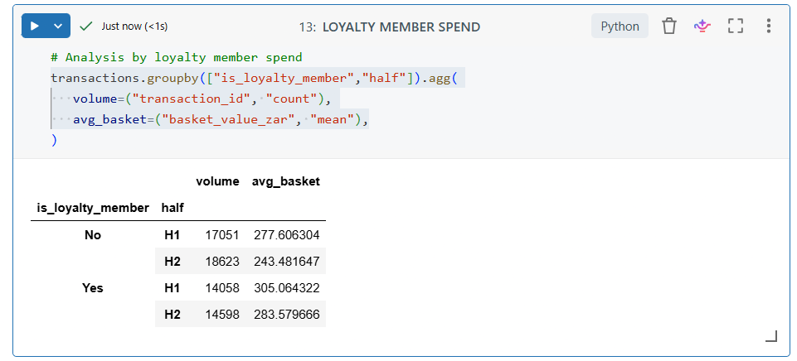
Loyalty members spend more per basket and decline more slowly than non-members.
Non-members declined 12.3% vs 7.0% for loyalty members — H3 partially supported: loyalty cushions the decline but doesn't explain it on its own, since even members declined.

Competitor proximity (H1)
This needed a proper event study rather than a chain-wide split: for the 12 stores where a discount competitor opened nearby, I compared each store's own transactions before vs after its actual competitor_open_date, then benchmarked that against stores with no nearby competitor over the same H1/H2 window.
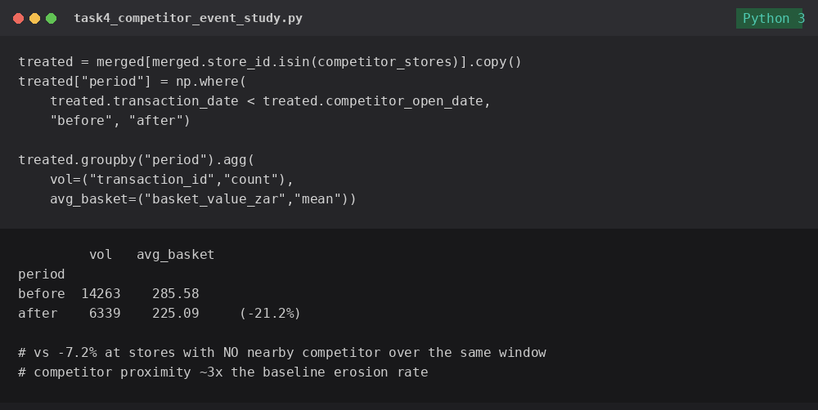
Event-study comparison: competitor-exposed stores vs the chain-wide baseline decline.
This was the strongest single result in the whole analysis: exposed stores fell 21.2% vs 7.2% for everyone else — competitor proximity roughly triples the erosion rate. H1 strongly supported.
I also checked store format and province as cross-cuts: the decline showed up everywhere (roughly –9% to –11% in every format and province), confirming this is a chain-wide phenomenon that competition then amplifies locally — not a one-region problem.

Task 5 — Findings and Root Cause
Pulling the segments together into a root-cause story meant checking whether the falling average was one thing (everyone spending a little less) or a mix-shift (the kind of trip changing).
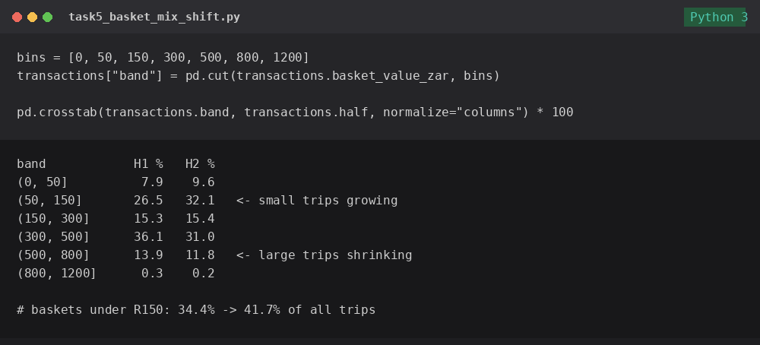
Distribution shift: small (top-up) baskets are a growing share of all trips, large baskets a shrinking share.
H2 supported: the share of baskets under R150 grew from 34.4% to 41.7%, while R300–800 baskets fell from 50.0% to 42.8%. This is a genuine change in shopping behaviour — more frequent, smaller trips — consistent with the volume-up/basket-down paradox from Task 1, and it guards against being fooled by a simple average.
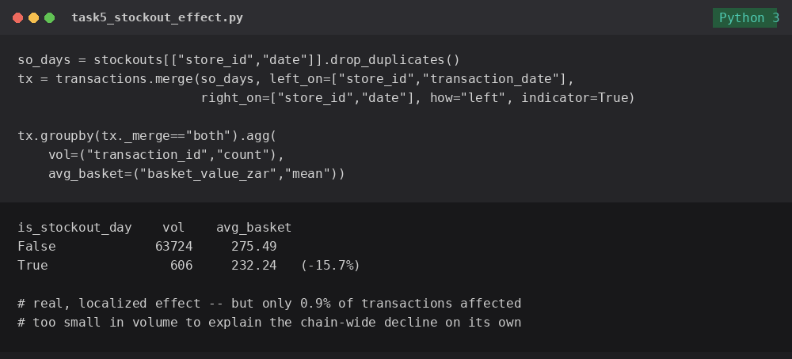
Stockout-day baskets are meaningfully smaller, but the affected volume is small.
H4 partially supported: stockout days show a real 15.7% drop in basket value, but they only touch 0.9% of transactions — a genuine operational leak, but not large enough to be a root cause of the chain-wide trend.
Synthesis: the decline is real, chain-wide, and driven mainly by a behavioural shift toward smaller, more frequent trips (H2), sharply compounded by direct discount competition at a subset of stores (H1, ~3x the baseline rate). Loyalty status moderates the effect (H3) but doesn't prevent it. Stockouts are a real but small contributor (H4).

Task 6 — Recommendations, Metrics and Monitoring
Each recommendation was tied back to the specific piece of evidence that supported it, so nothing in the deck was a suggestion without a chart behind it.
# | Recommendation | Evidence | Owner
1 | Competitive response (price-match / promos / loyalty offers) at the 12 exposed stores, prioritised by exposure date | 3x erosion rate near new competitors | Pricing Manager
2 | Cross-merchandising / multi-buy promos to grow small top-up trips, esp. in Express format | Mix-shift toward sub-R150 trips | Merchandising Lead
3 | Loyalty sign-up push targeting the 55% non-loyalty transaction base | Non-members decline faster | Head of Retail Ops
4 | Fix stockout logging beyond one category; prioritise availability on high-velocity lines | 15.7% basket hit on stockout days | Store Operations
5 | Monthly monitoring dashboard split by competitor exposure | Needed to test #1–#4 fairly | BA / Analytics

Success metrics and test design: average basket value and items per trip tracked monthly by store and competitor-exposure status; basket-size band mix; loyalty penetration; stockout incidence. To measure impact fairly, I proposed treating the competitor-exposed stores as a treatment group against a matched control group of similar stores with no nearby competitor — the same before/after design already used to isolate the competitor effect in Task 4.

How I Got to the Conclusion — Summary of the Workflow
- Started from the arithmetic of the paradox (Task 1) to get a quantified, real effect before looking for causes.
- Fixed stakeholders and wrote down competing hypotheses in advance (Task 2), so the analysis was testing ideas, not fishing for a story.
- Profiled and documented the data honestly (Task 3), including deciding that the missing customer_id values were structural, not dirty data.
- Rejected the chain-wide average as the answer and segmented by loyalty, format, province and — critically — an event study around actual competitor opening dates (Task 4).
- Checked the shape of the data, not just the mean, to catch the mix-shift toward smaller trips, and sized the stockout effect honestly instead of over-claiming it (Task 5).
- Tied every recommendation to a specific finding and proposed a fair, matched before/after test design to monitor impact going forward (Task 6).

Strategic Recommendations for Freshmart Retail Performance

📊 Key Performance Insights
Overall Performance (2025)
- Total Revenue: R17.7M across 64,330 transactions
- Average Basket: R275.08 with 13.45 items per transaction
- Geographic Leaders: Gauteng dominates with R8.4M (48% of revenue), followed by Western Cape (R5.8M) and KwaZulu-Natal (R3.4M)

🏪 Store Format Optimization

Current Performance by Format:
- Medium Format: R276.69 avg basket (highest)
- Large Format: R274.34 avg basket, 31,441 transactions (highest volume)
- Express Format: R273.05 avg basket, 8,115 transactions

Recommendations:
- Expand Medium format stores - They deliver the highest average basket value while maintaining good transaction volume (24,774)
- Optimize Express stores - While they have similar basket values, their lower transaction volume suggests potential for better site selection or marketing
- Leverage Large format strength - These drive the highest transaction volume; focus on maintaining traffic while working to increase basket size through cross-selling

👥 Loyalty Program Enhancement
Current State:
- Non-members: R9.3M revenue (52.4%)
- Loyalty members: R8.4M revenue (47.6%)
Critical Finding: Despite similar numbers, loyalty members likely have higher frequency/lifetime value. Investigate:
- Member vs non-member transaction frequency
- Average basket comparison (not just total revenue)
- Member retention and repeat purchase rates
Action Items:
- Aggressive enrollment campaign - The nearly 50/50 split suggests untapped potential
- Tiered rewards program - Incentivize higher basket values for members
- Personalized promotions - Use purchase data to drive targeted offers

🏢 Competitive Response Strategy

Stores Facing Competition:
- Multiple stores show "Yes" for nearby competitors (FreshMart Pretoria 3, Pretoria 6, etc.)
- Avg basket values for stores with competitors: R266-271 vs R276-292 for non-competing stores
Immediate Actions:
- Price competitiveness audit - Focus on stores with nearby competition
- Service differentiation - Enhance in-store experience and convenience
- Localized promotions - Target customers in competitive zones with special offers
- Basket-building initiatives - Cross-merchandising and bundling to increase transaction value

📈 Seasonal & Trend Opportunities

Key Observations:
- H1 performance (R290 avg basket) outperforms H2 (R261 avg basket) by 11%
- Transaction volume peaks in November-December (5,829 and 5,674 respectively)
- February shows the lowest volume (4,840 transactions)
Recommendations:
- H2 promotion strategy - Aggressive campaigns in Q3-Q4 to close the gap with H1
- February revival campaign - Address the post-holiday slump with targeted promotions
- Inventory planning - Align stock levels with seasonal patterns to minimize stockouts during peak periods

💳 Payment Method Insights

Distribution:
- Card: 50.2% (32,306 transactions) - Dominant
- Cash: 30.7% (19,754 transactions)
- Mobile: 19.1% (12,270 transactions) - Growing segment
Actions:
- Mobile payment promotion - This is the future; incentivize adoption with cashback/discounts
- Contactless infrastructure - Ensure all stores have modern payment terminals
- Digital wallet partnerships - Integrate with major mobile money platforms

🎯 Geographic Expansion Strategy

Current Distribution & Recommendations:
- Gauteng (R8.4M) - Continue to dominate; add 2-3 medium format stores in underserved areas
- Western Cape (R5.8M) - Strong second market; identify opportunities for Large format stores
- KwaZulu-Natal (R3.4M) - Growth opportunity; consider 1-2 Medium format stores to test market expansion

📋 Action Priority Matrix

Immediate (Next 30 days):
- Competitive pricing audit for stores with nearby competitors
- Launch February revival promotion
- Mobile payment adoption campaign
Short-term (90 days):
- Loyalty program enhancement and enrollment drive
- H2 performance improvement initiatives
- Site selection for new Medium format stores
Long-term (6-12 months):
- Geographic expansion into KwaZulu-Natal
- Large format optimization program
- Advanced inventory management system implementation

